Graded Unit project

Silicon Croft Website

# Action Plan

## Analysis of the Project Brief

### Project Brief

Mesomorphic is a small Shetland based software development company who create bespoke software for small and medium sized enterprises using modern development methodologies. They have asked me to create a prototype website for an ongoing project called Silicon Croft that they can later extend. They also want me to source and set up a new server, and install all software required to host the website. They have a very restrictive budget and thus open-source software, and pre-existing solutions should be used where possible. The website must be responsive as a broad range of devices are used extensively in educational environments and the greater world, and the website needs to work well under all conditions. Although the company is based in software development some of their staff who will be adding content to the website will have little or no background in software.

I have been asked to clarify the requirements of the project then identify, source, and implement a suitable hardware and software platform, install and configure the software and set up a website prototype which the company can then later extend.

### Problem Analysis

* A server hosting solution must be found that meats the very restrictive budget allocated for the project.
* The server provided by the hosting provider must be capable of running all the software required to host the website.
* Suitable software packages that together are suitable for hosting the prototype website will have to be researched and chosen.
* All the software we require to host the website must then be installed on to the server.
* Designing a responsive website from scratch is out of the scope of this project and thus careful selection of supporting tools and packages must be made to ensure the completion of the project on time.
* As some of the staff adding content do not have a background in software or web development adding content to the website will have to be as simple as possible and so the obvious solution is to use a suitable Content Management System.
* The website will have to be database-driven as staff members who have little to no experience in web development would not be able to modify source code in order to add content to the website without significant training.
* The website must be responsive and able to function to a high standard on as many platforms as possible. If the website is not responsive, then it will not look as intended on all platforms and may even not function properly on some.
* Third party installers don’t normally want to service a system if they didn’t set-up so most likely any maintenance will have to be performed in-house which would suggest that commonly used software packages should be preferred to reduce the chances of the in-house staff not being able to easily find a solution to any issues they have in the future.

### Aims

* Source a suitable server, install server software and configure the server as per the requirements of the client.
* Install and configure a Content Management System so that non-technical staff within the client’s company are able to add content to the website with minimal training.
* Produce a manual to train staff in how to use the Content Management System to add content to the website.
* Produce a responsive prototype website that looks good and functions on as many platforms as possible.

### Requirements

#### Functional

* The website must follow the style guide and keep in style with the graphics provided by the client as examples.
* The website must be responsive and function to a high standard on a wide range of devices and web browsers.
* The website must be data driven and allow simple addition, deletion and updating of database entries.
* The website must be easy to use for all targeted audiences (educators, students, technology-based companies) and the greater public, it must have clear, easy to follow navigation.
* The website should be designed and developed using up to date tools, technologies and techniques and, follow current web standards.
* Users of the website need to be able to easily find information about Silicon Croft that is relative to them based on the kind of user they are.

#### Non-functional

* The hosting provider for the web server must be geographically close to the client’s business as most of the people who visit the website will be within a limited geographical range of the client and this will avoid high ping times which can significantly impact the user experience.
* The server will require a modern operating system which is regularly kept up to date to ensure that it is as secure as possible.
* The server will need to be powerful enough to run
* The server will require a database to store content for the website and for the CMS to integrate with.
* The server will need a server-side scripting language installed for the CMS to be able to utilise the database.

#### Constraints

* The website must be completed and fully operational by 3rd May 2022.
* There is no budget for the project and so open-source software will have to be used and free solutions will have to be found for any and all problems.

### Key Factors

* The website must be responsive and support as many browsers and devices as possible.
* The website must be user friendly with an easy to understand layout and simple navigation.
* The website must be database driven and use a CMS to allow non-technical users to easily add content.
* The server that is selected must be powerful enough to be able to run the website.

### Resources and materials

#### Hardware

* A computer that is powerful enough to run all the software required for the design and development of the project will be required however this is not a very high requirement especially as the software has quite low requirements by modern standards. As my personal computer is of a reasonably high spec by modern standards it will have no problem running all of the software I will be using.
* A mobile device and a tablet to test the usability and responsiveness of the website on smaller devices and at different resolutions. The mobile will be an iPhone 8 Plus, and the tablet a Samsung Galaxy Tab A7, as these are the devices I have available to me personally.
* A server that is capable of running the software platform chosen, any plugins chosen and the website. The University Of The Highlands and Islands is providing a virtual server that is capable of running all the required software specifically for this project and so I will be using that.

#### Software

* A text editor will be required to produce source code and scripts, to edit configuration files and modify any other text files required. I have a personal licence for a text editor called Sublime Text that I will be using as I am familiar with it, and it is more than suitable for the needs of this project.
* A word processor will be required to produce the manual (To train the client’s staff on adding content to the website) and any other documentation required. As I am a student of UHI I am provided free access to the Microsoft Office suite which includes Microsoft Word which I will be using for this purpose.

#### Procedure

1. I will at times be using a program called Sublime Text which I have a personal licence for to edit text files and I will have to ensure that it’s use for this purpose does not go against any of the terms of this licence.
2. A suitable software platform and hosting provider will have to be identified and chosen to be used as the server where the website will be hosted. As we are going to be using the virtual server provided by the college for this, we will have to ensure that our usage is allowed under the college’s acceptable use of college equipment policies.
3. The server will have to have all the required software installed and any changes made to the configuration files to prepare it for the website.
4. Any plugins for the CMS that we wish to use will have to be installed and configured.
5. The layout and general style will have to be planned out and a site map will have to be created.
6. Any assets required for the website will have to be created.
7. All content to be included in the prototype website will have to be created.
8. The database will have to be populated with any data required for the website and the assets provided by the client as well as any created. As we are using assets from the client, we will have to keep in mind that these assets are copyrighted by the client and so we will have to ensure we do not breach any laws pertaining to the use of copyrighted assets on behalf of a client.
9. The pages will have to be created as detailed in the sitemap that was created earlier.
10. All contents will have to be added to the created web pages.
11. A manual will have to be created to train staff on how to add content to the website.
12. The website will have to have all navigation links tested
13. The website will have to have the functionality of each webpage tested in order to make sure they are all working as expected.
14. The responsiveness of the website will have to be tested by trying it on one tablet device and one mobile device and ensuring that it works as expected on each device.
15. Any bugs found during implementation or testing will have to be fixed before the website can be handed over to the client.

### Information Sources

#### Official Websites

* [WordPress.com](https://wordpress.com/)
* [PHP: Hypertext Preprocessor](https://www.php.net/)
* [MariaDB Foundation](https://mariadb.org/)
* [Microsoft](https://www.microsoft.com/en-gb/)
* [Squarespace](https://www.squarespace.com/)

#### Forums and Tech Help Websites

* [StackOverflow](https://stackoverflow.com/)
* [CodeProject](https://www.codeproject.com/)
* [Microsoft Support](https://support.microsoft.com/)
* [Server Fault](https://serverfault.com/)
* [Database Administrators Stack Exchange](https://dba.stackexchange.com/)

#### Client Supplied Information

* [Style Guide - Google Docs](https://docs.google.com/document/d/1YeYWP7FQM1vQ_INMrNShCmJTp7vfx7H5jEpZaGATgRQ/edit)
* [Silicon Croft initial meeting 8 Feb 22.docx - Google Docs](https://docs.google.com/document/d/1kgQwZJW1crh8AhNB3lt2ILDeANeMkvwN/edit)
* [Cultivating Silicon Croft - Google Docs](https://docs.google.com/document/d/1GpO_FR-QnpvF1GcbQBH_30KV-F0a26JVsPTtVrUgRNw/edit#heading=h.5f1gh4kvvaa6)
* [Logos.zip - Google Drive](https://drive.google.com/file/d/1UcE1a5qFgybXyCBY2YVEaKVw32xg6MMr/view)

#### Books

* Apache HTTP Server Documentation Version 2.5 ([Amazon UK](https://www.amazon.co.uk/Apache-HTTP-Server-Documentation-Version/dp/1680921487/ref=sr_1_1?keywords=%E2%80%A2+Apache+HTTP+Server+Documentation+Version+2.5&qid=1651079373&sr=8-1))

### Analysis

Information will be gathered and used from the following sources:

* An initial meeting was held with the client to gain more information as to what they expected the outcome of the project to be and to ensure that we both had the same view of the final product.
* Official documentation will be used as much as possible to determine what platform and software components would be most suitable for hosting and producing the type of website that is required by the client.
* A second meeting is scheduled with the client and information gathered from this meeting will also be used as much as possible in guiding the project in the direction desired by the client.
* I will use the Official Apache HTTP Server Documentation Book as a reference to help in setting up the server.
* I will use a number of forums and tech help websites as listed above to help me in bug detection and fixing.

## Project Plan

### Timescale

The project has been moved back and will now have to be accelerated as I was unable to work on the project for several weeks. The project will now run from 10/05/2022 until 28/05/2022 at which point it must be complete and all deliverables must be in the hands of the client. A gantt chart has been produced to show the expected schedule for each task and it’s individual assignments.

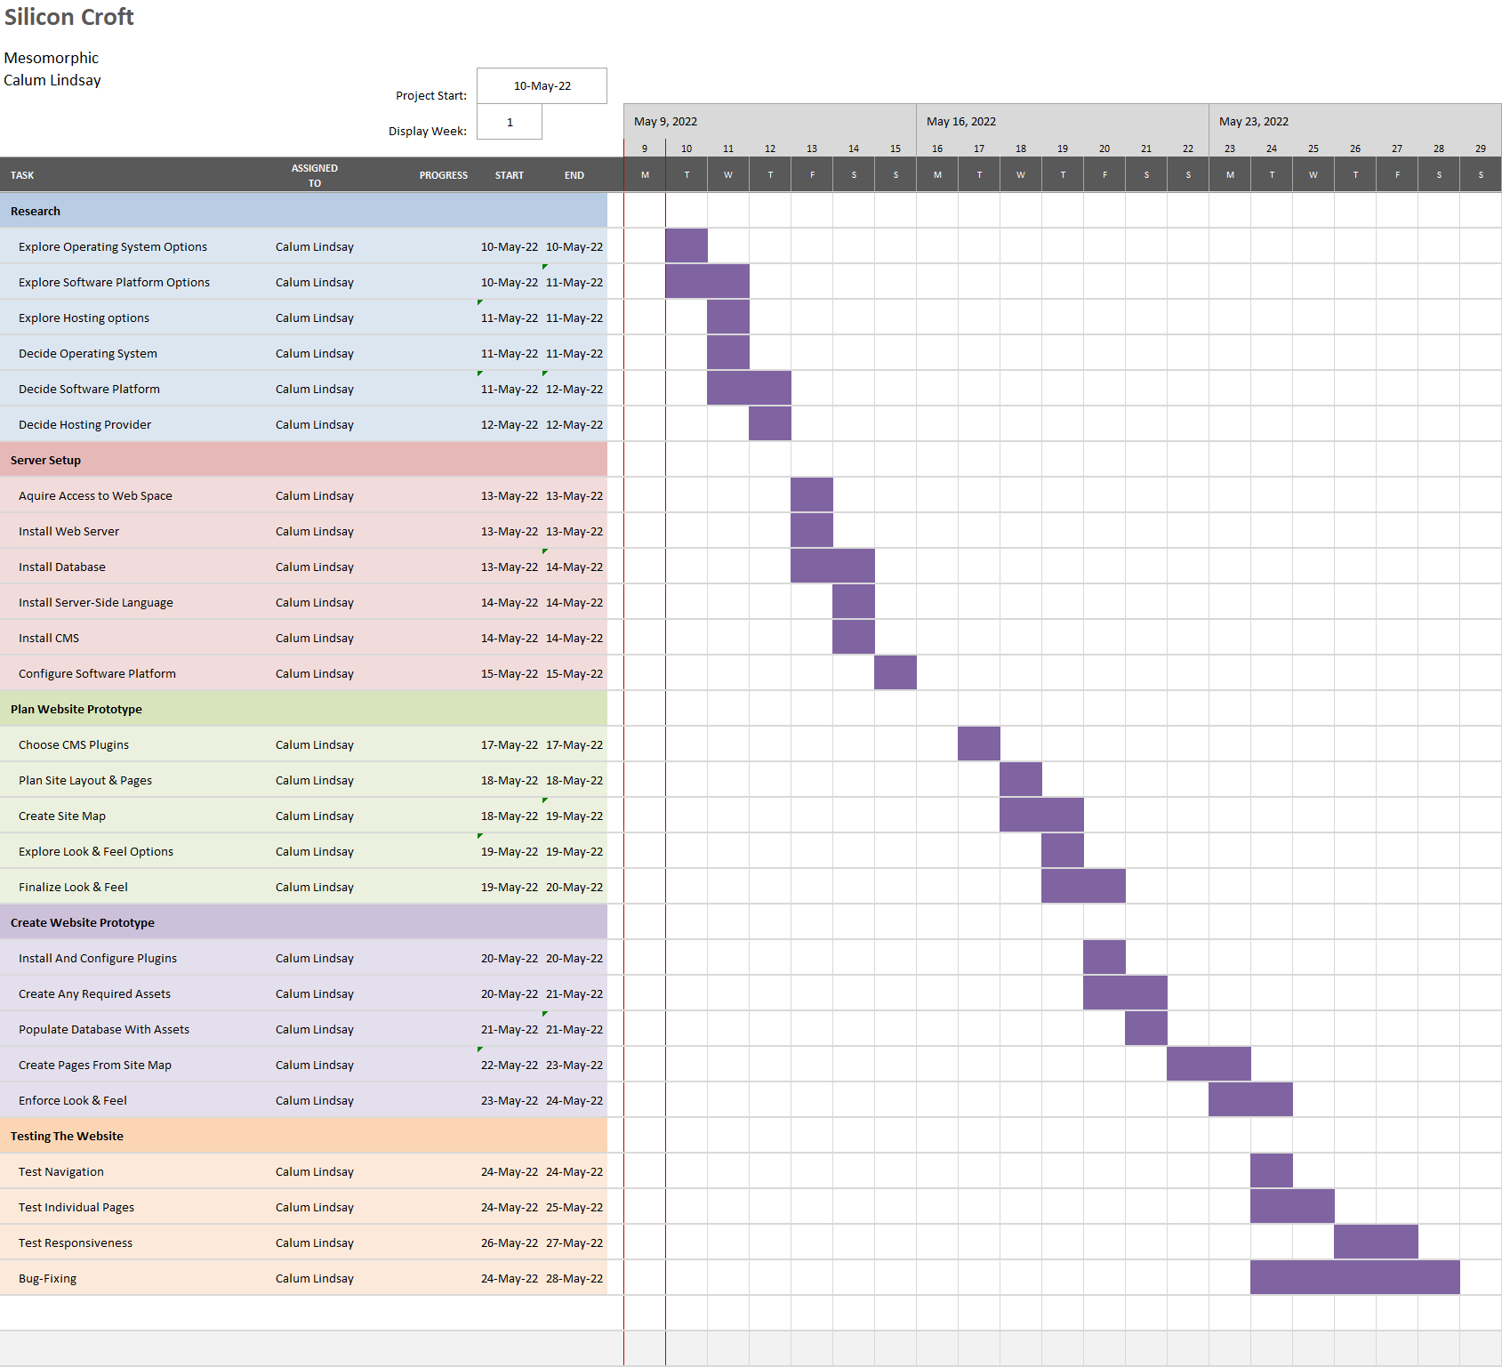

### Milestones and Deliverables

* Access to a server with all software installed and configured that is required to host the prototype website requested by the client.
* A manual detailing how to add content to the website using the CMS installed for non-technical staff employed by the client’s company who will be adding content to the website.
* A site map that shows all web pages included in the prototype and shows the navigation paths possible between them.
* The prototype website requested by the client that can be later extended and modified by the client.

### Main Tasks

* Identification of and acquisition of a suitable hardware and software platform.
* Installation and configuring of all required software.
* Planning of the website prototype.
* Creation of the website prototype.
* Testing of the completed project before hand-off to the client.

### Resources

* I am the only person who will be working on the project and will be performing every aspect of all tasks and assignments.
* I will require a computer powerful enough to run all the software I will be using to complete the project.
* I will require 1 tablet device and 1 mobile device to test the responsiveness of the website once completed.
* I will not require any facilities to complete the project as everything will be done remotely from home or on the move.
* The project has no funding and so everything must be done at zero cost to the client and myself.